This document describes the basic understanding of Rest API HTTP methods.

Reference Link:

https://www.restapitutorial.com/lessons/httpmethods.html

Example 1:

groupId: com.practice

artifactId: hibernateExample1Controller
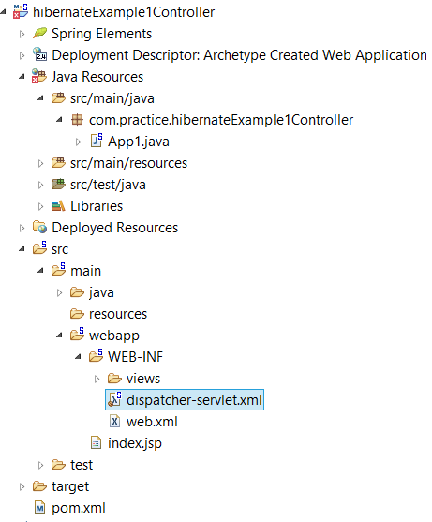
Pom.xml:
<properties>
<project.build.sourceEncoding>UTF8</project.build.sourceEncoding>
<maven.compiler.source>11</maven.compiler.source>
<maven.compiler.target>11</maven.compiler.target>
</properties>
<dependencies>
<dependency>
<groupId>junit</groupId>
<artifactId>junit</artifactId>
<version>3.8.1</version>
<scope>test</scope>
</dependency>
<dependency>
<groupId>org.springframework</groupId>
<artifactId>spring-web</artifactId>
<version>5.3.9</version>
</dependency>
<dependency>
<groupId>org.springframework</groupId>
<artifactId>spring-context</artifactId>
<version>5.3.9</version>
</dependency>
<dependency>
<groupId>org.springframework</groupId>
<artifactId>spring-webmvc</artifactId>
<version>5.3.9</version>
</dependency>
<dependency>
<groupId>com.fasterxml.jackson.core</groupId>
<artifactId>jackson-databind</artifactId>
<version>2.12.3</version>
</dependency>
<dependency>
<groupId>com.fasterxml.jackson.core</groupId>
<artifactId>jackson-core</artifactId>
<version>2.12.3</version>
</dependency>
<dependency>
<groupId>javax.servlet</groupId>
<artifactId>javax.servlet-api</artifactId>
<version>4.0.1</version>
<scope>provided</scope>
</dependency>
<dependency>
<groupId>org.springframework</groupId>
<artifactId>spring-messaging</artifactId>
<version>5.3.9</version>
</dependency>
<dependency>
<groupId>org.springframework</groupId>
<artifactId>spring-websocket</artifactId>
<version>5.3.9</version>
</dependency>
<dependency>
<groupId>org.apache.commons</groupId>
<artifactId>commons-dbcp2</artifactId>
<version>2.7.0</version>
</dependency>
<dependency>
<groupId>commons-io</groupId>
<artifactId>commons-io</artifactId>
<version>2.7</version>
</dependency>
<dependency>
<groupId>javax.websocket</groupId>
<artifactId>javax.websocket-api</artifactId>
<version>1.1</version>
<scope>provided</scope>
</dependency>
<dependency>
<groupId>commons-fileupload</groupId>
<artifactId>commons-fileupload</artifactId>
<version>1.3.3</version>
</dependency>
</dependencies>
Web.xml
<!DOCTYPE xml>
<web-app id="WebApp_ID" version="2.4"
xmlns="http://java.sun.com/xml/ns/j2ee"
xmlns:xsi="http://www.w3.org/2001/XMLSchema-instance"
xsi:schemaLocation="http://java.sun.com/xml/ns/javaee http://java.sun.com/xml/ns/j2ee/web-app_2_4.xsd">
<display-name>Archetype Created Web Application</display-name>
<servlet>
<servlet-name>dispatcher</servlet-name>
<servlet-class>org.springframework.web.servlet.DispatcherServlet</servlet-class>
<load-on-startup>1</load-on-startup>
</servlet>
<servlet-mapping>
<servlet-name>dispatcher</servlet-name>
<url-pattern>/</url-pattern>
</servlet-mapping>
<listener>
<listener-class>org.springframework.web.context.ContextLoaderListener</listener-class>
</listener>
<context-param>
<param-name>contextConfigLocation</param-name>
<param-value>
/WEB-INF/dispatcher-servlet.xml
</param-value>
</context-param>
</web-app>
dispatcher-servlet.xml
<beans xmlns="http://www.springframework.org/schema/beans"
xmlns:context="http://www.springframework.org/schema/context"
xmlns:websocket="http://www.springframework.org/schema/websocket"
xmlns:xsi="http://www.w3.org/2001/XMLSchema-instance"
xmlns:webflow="http://www.springframework.org/schema/webflow-config"
xmlns:mvc="http://www.springframework.org/schema/mvc"
xsi:schemaLocation="http://www.springframework.org/schema/beans
http://www.springframework.org/schema/beans/spring-beans.xsd
http://www.springframework.org/schema/mvc
http://www.springframework.org/schema/mvc/spring-mvc.xsd
http://www.springframework.org/schema/websocket
http://www.springframework.org/schema/websocket/spring-websocket.xsd
http://www.springframework.org/schema/context
http://www.springframework.org/schema/context/spring-context.xsd">
<context:component-scan
base-package="com.practice.hibernateExample1Controller" />
<mvc:annotation-driven />
<mvc:default-servlet-handler />
<!-- <websocket:message-broker application-destination-prefix="/app"> <websocket:stomp-endpoint
path="/chat"> <websocket:sockjs></websocket:sockjs> </websocket:stomp-endpoint>
<websocket:simple-broker prefix="/topic" /> </websocket:message-broker> -->
<bean
class="org.springframework.web.servlet.view.InternalResourceViewResolver">
<property name="prefix">
<value>/WEB-INF/views/</value>
</property>
<property name="suffix">
<value>.html</value>
</property>
</bean>
<!-- <bean id="multipartResolver" class="org.springframework.web.multipart.commons.CommonsMultipartResolver">
<property name="maxUploadSize" value="10000000" /> </bean> -->
</beans>
App1.java
package com.practice.hibernateExample1Controller;
import java.util.ArrayList;
import java.util.List;
import org.springframework.http.HttpStatus;
import org.springframework.http.MediaType;
import org.springframework.http.ResponseEntity;
import org.springframework.web.bind.annotation.DeleteMapping;
import org.springframework.web.bind.annotation.GetMapping;
import org.springframework.web.bind.annotation.PathVariable;
import org.springframework.web.bind.annotation.PostMapping;
import org.springframework.web.bind.annotation.RequestBody;
import org.springframework.web.bind.annotation.RestController;
@RestController
public class App1 {
// http://localhost:8080/hibernateExample1Controller/student/2
// See the Body Preview & Status
@GetMapping(path = "/student/{rollNo}", produces = { MediaType.APPLICATION_JSON_VALUE })
public ResponseEntity<String> getStudent(@PathVariable Integer rollNo) {
if (rollNo == 2) {
String msg = "Hi " + rollNo;
return new ResponseEntity<String>(msg, HttpStatus.OK);
} else {
return new ResponseEntity<String>("Student Not Found", HttpStatus.BAD_REQUEST);
}
}
// http://localhost:8080/hibernateExample1Controller/students
// See the Body Preview & Status
@GetMapping("/students")
List<String> studentsList() {
List<String> students = new ArrayList<>();
students.add("Komal");
students.add("Hitesh");
return students;
}
// http://localhost:8080/hibernateExample1Controller/student
// Go to body, Select raw and type: {"student":"Komal"} and check the status
@PostMapping("/student")
ResponseEntity<String> newStudent(@RequestBody String student) {
if (student != null) {
return new ResponseEntity<String>(student, HttpStatus.OK);
} else {
return new ResponseEntity<String>("Student is Null", HttpStatus.BAD_REQUEST);
}
}
// http://localhost:8080/hibernateExample1Controller/student/2
// Check the status
@DeleteMapping(path = "/student/{rollNo}")
ResponseEntity<Integer> deleteEmployee(@PathVariable Integer rollNo) {
if (rollNo != null) {
return new ResponseEntity<Integer>(HttpStatus.OK);
} else {
return new ResponseEntity<Integer>(HttpStatus.BAD_REQUEST);
}
}
}

